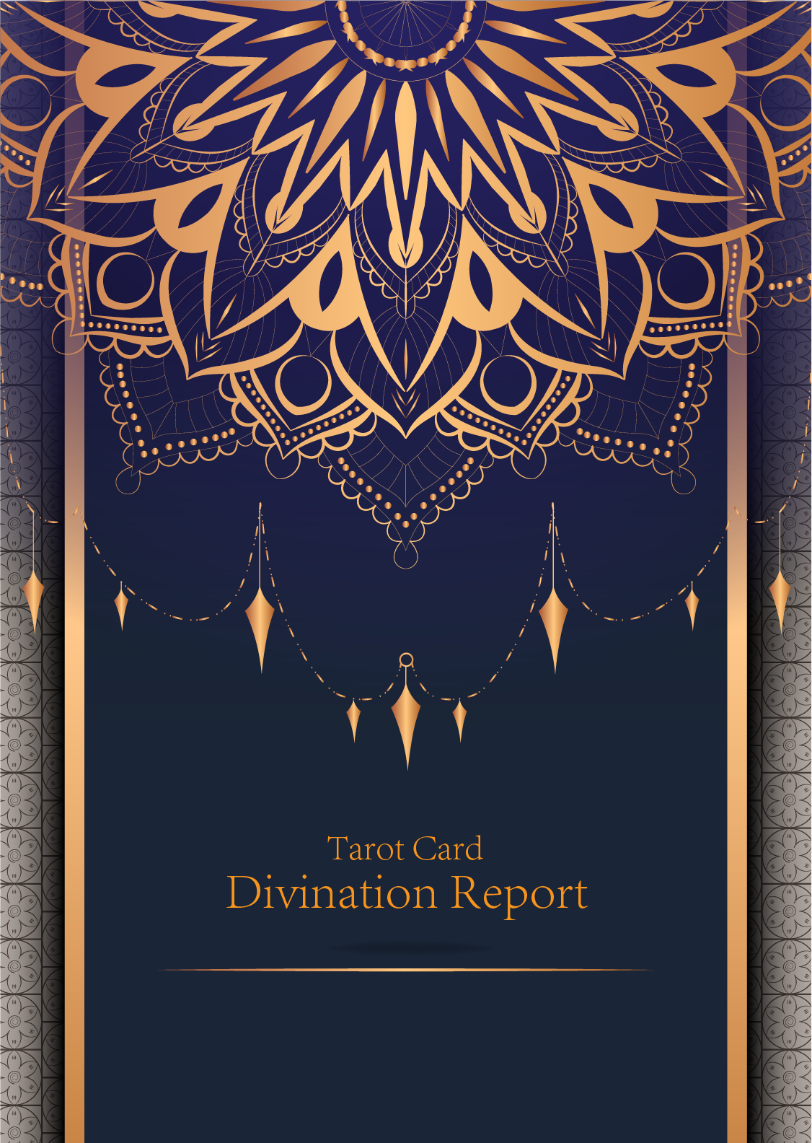

|  |
| --- |
| February 23, 2024 |

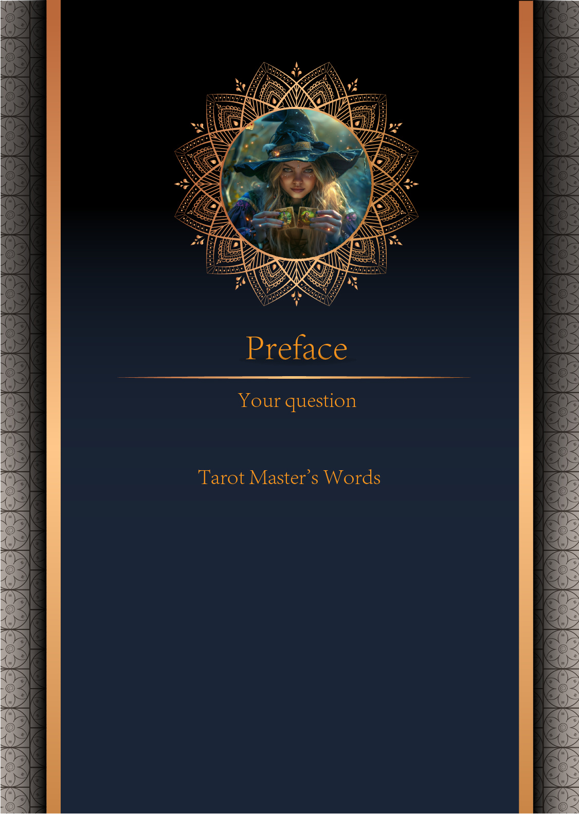

|  |
| --- |
| 我什么时候能结婚 |

|  |
| --- |
| Before we begin the interpretation, I would like to explain some important points to you. Tarot cards are not tools for predicting the future, but rather tools for guiding us to delve deeper into various situations in life. Therefore, when receiving the reading, please maintain an open mindset and trust your intuition. Our goal is to provide you with inspiration and guidance through the guidance of the tarot cards, helping you better deal with challenges and decisions in life. Alright, you can start reading now! |

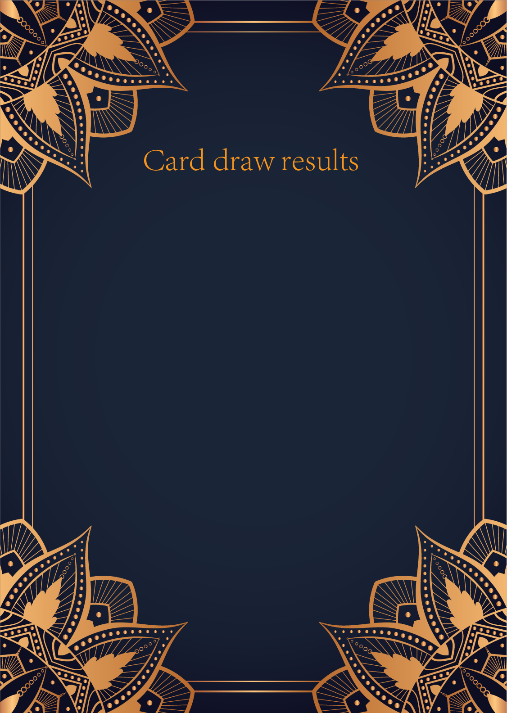

|  |
| --- |
| CardⅠ The Sun |
|  |
| The Sun card presents an feeling of optimism and fulfillment. This card represents the dawn which follows the darkest of nights. The Sun is the source of all the life on our planet, and it represents life energy itself. There is a child depicted in the card, playing joyfully in the foreground. A symbol of our innocence, it represents the happiness that occurs when you are in alignment with your true self. The child is naked, meaning that he has absolutely nothing to hide. The card also depicts the childhood innocence and absolute purity. This is particularly emphasized through the white horse upon which the child is riding. The horse here is also a symbol of strength and nobility. |

|  |
| --- |
| CardⅡ The Moon |
|  |
| When we encounter the Moon, we see a path that leads off into the distance. On either side of the path stand a wolf and a dog, representing our animalistic nature - one is civilized, and the other wild and feral. There is a crawfish that is crawling out of the pond from which the path stems from. In the distance, we can see two towers flanking the central path, once again alluding to the doubles visible in this card. Everything in this card seems to echo the other, as if to allude to two possibilities. When we walk down the path, we walk the fine line between conscious and unconscious, between the tamed side of civilization of the dog, and the forces of nature represented by the wolf. |

|  |
| --- |
| CardⅢ The Star |
|  |
| The Star card shows a woman kneeling at the edge of a small pond. She is holding two containers of water. One container pours the water out to the dry land, as if to to nourish it and ensure its fertility. The lush green land around her seems to say that it is working. One foot is inside the water which shows the spiritual abilities and inner strength of the woman. The other foot on the ground shows her practical abilities and strengths. Behind her, there is a large central star surrounded by seven small stars which represent the chakras. There is bird standing at a tree branch which represents the holy ibis of thought. The Star's astrological correspondent is Aquarius. |

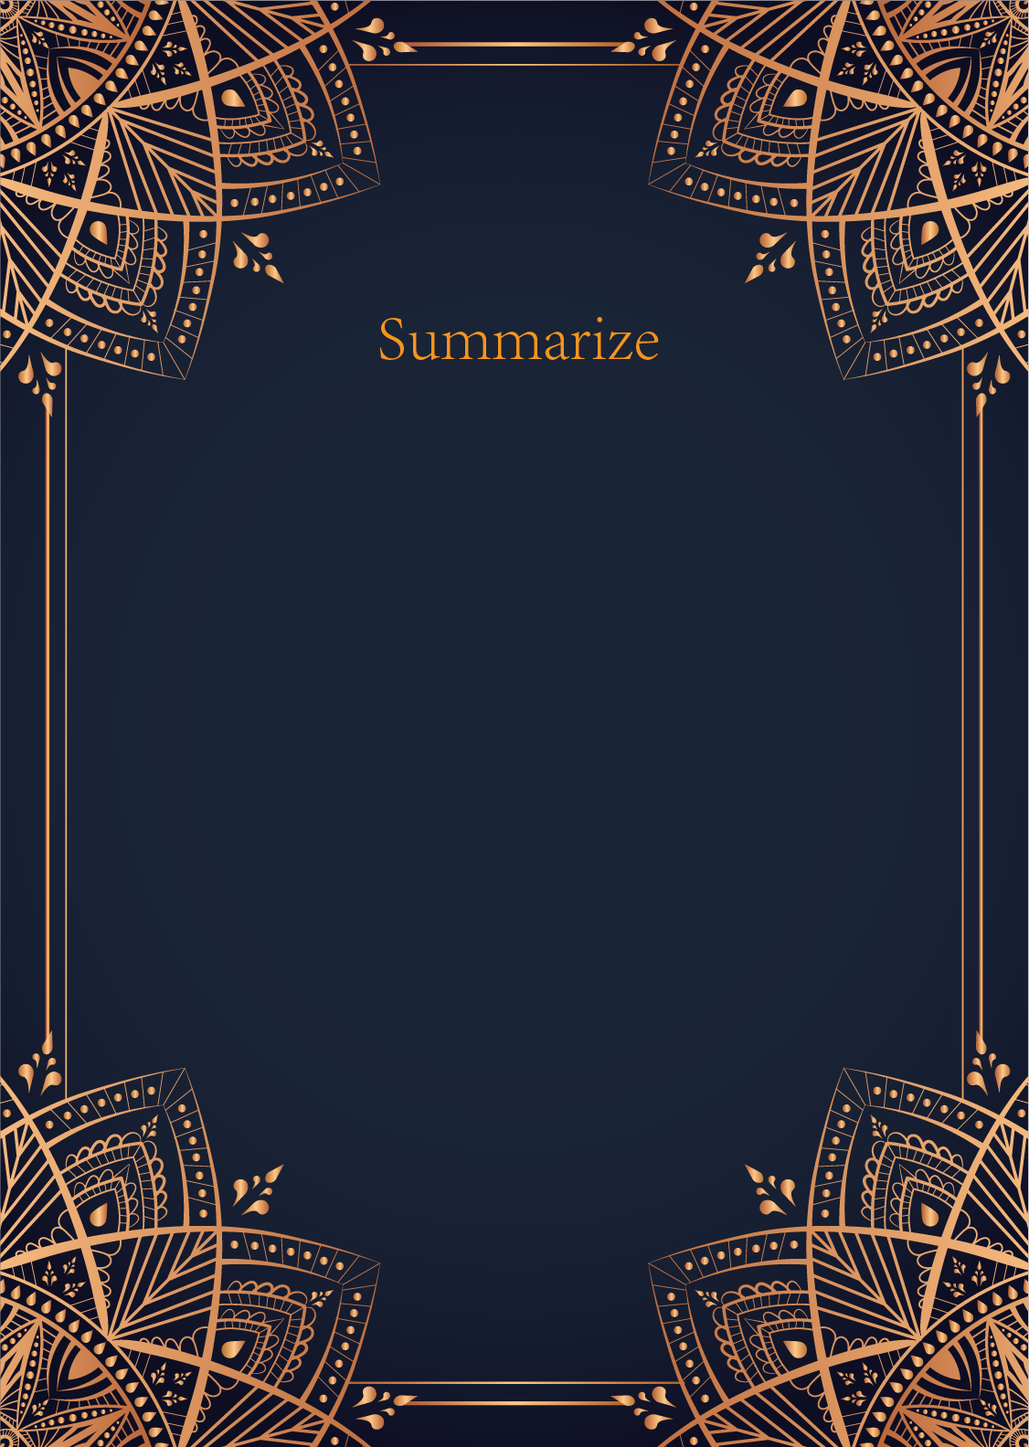

|  |
| --- |
| Ah, dear seeker, your question about when you will get married is one that reflects your desire for union and fulfillment. Let us delve into the mystical realm of the tarot to reveal the secrets hidden within the cards you have drawn: The Sun, The Moon, and The Star.  The Sun card shines brightly upon you, illuminating a period of joy, growth, and vitality in your love life. This card symbolizes success, happiness, and harmony in relationships. It suggests that you are currently in a phase of self-discovery and confidence, laying a strong foundation for a future partnership. The Sun card encourages you to embrace the present moment and bask in the warmth of love surrounding you.  On the other hand, The Moon card whispers of intuition, mystery, and unknown journeys. This card represents your inner emotions, dreams, and subconscious desires. It suggests that there may be hidden or confusing elements at play in your romantic endeavors. The Moon invites you to explore your deepest fears and desires, allowing you to uncover the truth that lies beneath the surface of your heart. It is a reminder to trust your instincts and navigate the shadows with courage and grace.  And finally, The Star card twinkles with hope, inspiration, and guidance. This card symbolizes faith, healing, and divine intervention in matters of the heart. The Star heralds a sense of peace and renewal, encouraging you to believe in the power of destiny and serendipity. It signifies that a wish is being granted and that your path is illuminated by the light of love. The Star invites you to embrace your true self and follow your heart's desires with unwavering faith.  In essence, the cards suggest that your journey towards marriage is a radiant and transformative one. The Sun indicates that a period of happiness and harmony is on the horizon, while The Moon warns of inner exploration and emotional depth. The Star brings a message of hope and fulfillment, guiding you towards a union that is written in the stars.  Therefore, dear seeker, trust in the magic of the tarot and the wisdom of the cards you have drawn. Your path towards marriage is a sacred and unfolding one, filled with light, shadow, and ultimately, love. Remember to embrace each moment with grace and intention, knowing that the universe is conspiring to bring you the union your heart yearns for. Surrender to the journey, for in its twists and turns, you will find the answer to your question. Blessed be. |

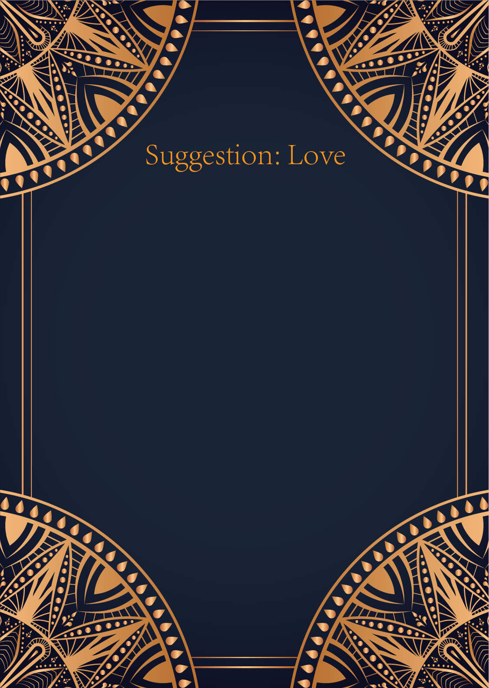

|  |
| --- |
| Ah, dear seeker of love, the cards have revealed to me a powerful message tailored just for you. The Sun, the Moon, and the Star, a glorious trio, shining brightly in the sky of your destiny.   The Sun symbolizes joy, success, and fulfillment in matters of the heart. It speaks of warmth, passion, and a deep connection with your true self. Embrace this energy in your relationships, let your love shine like a beacon, guiding you towards happiness and harmony.  The Moon, mysterious and intuitive, urges you to trust your instincts and explore the depths of your emotions. This card cautions against hidden fears and illusions that may cloud your judgment in matters of love. Look beyond the surface, listen to the whispers of your heart, and be open to the unknown.  And finally, the Star, a symbol of hope, inspiration, and divine guidance. This card encourages you to dream big, believe in the power of love to illuminate your path, and to have faith in the universe's plan for you. Let your heart be filled with optimism and trust in the magic of love.  In matters of love, my dear, the cards urge you to embrace the joy and passion that the Sun offers, to trust your intuition and delve deep into your emotions like the Moon, and to have faith in the greater plan and the endless possibilities of love like the Star.  Remember, love is a journey of discovery and growth. Embrace the light and darkness within yourself and your relationships, for it is in this balance that true love blossoms. May the energy of the Sun, the wisdom of the Moon, and the hope of the Star guide you on your path to love and fulfillment. Blessed be. 🌞🌙⭐ |

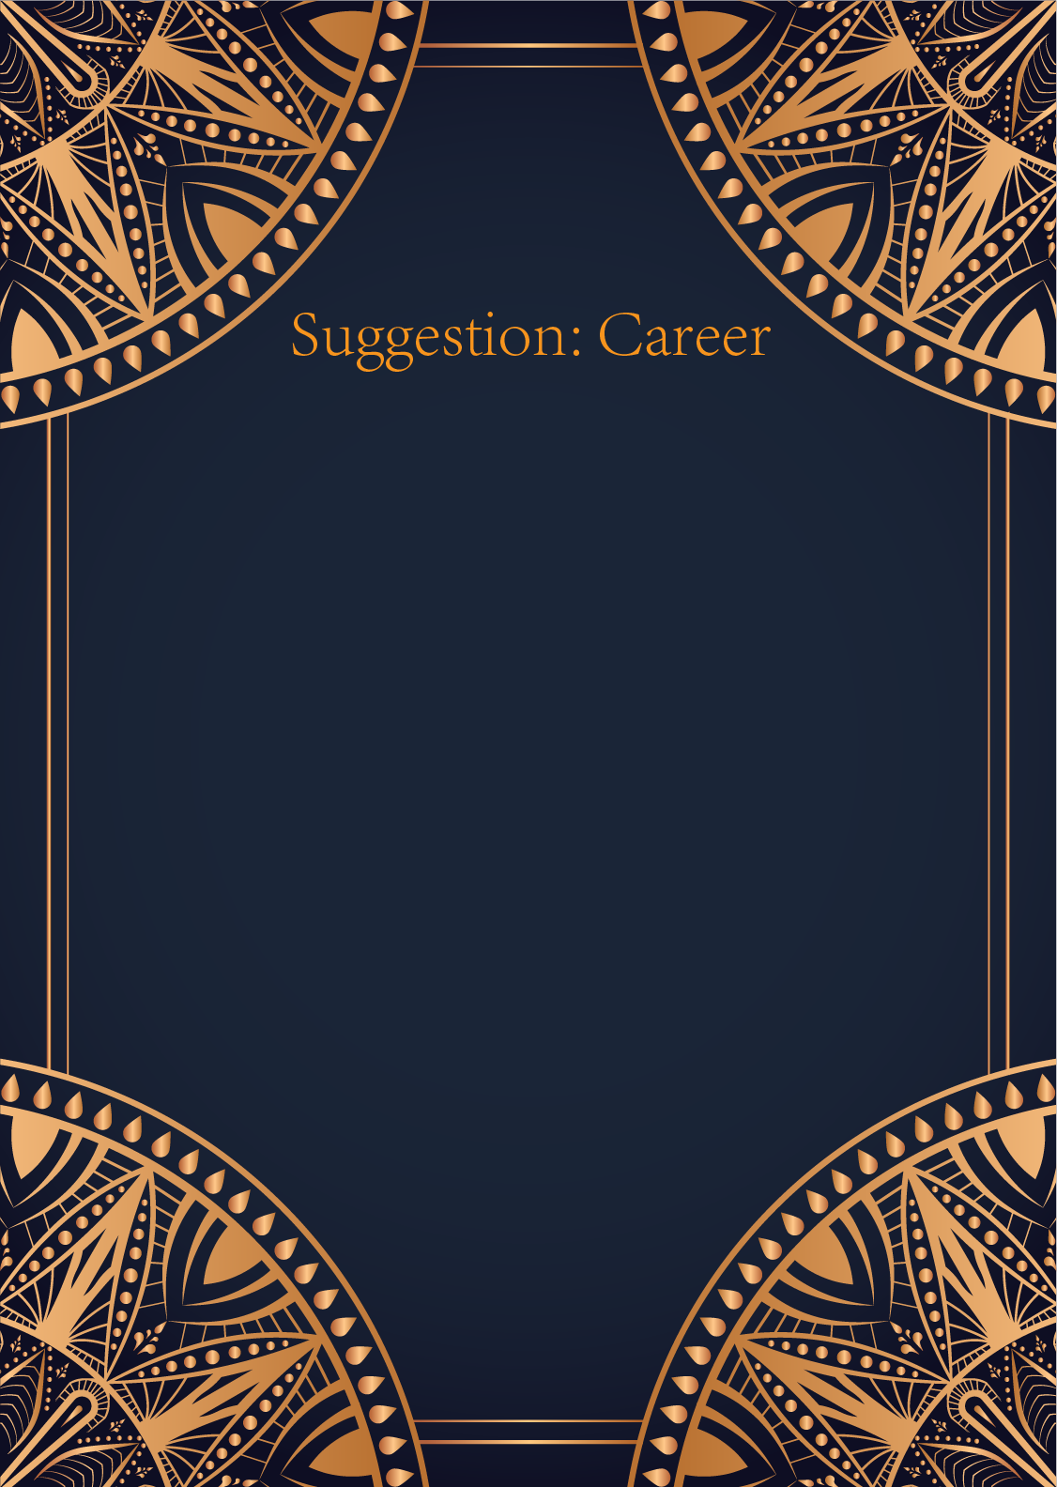

|  |
| --- |
| Ah, the Sun, the Moon, and the Star – a powerful trio of cards you have drawn today. The Sun represents success, joy, and vitality. It shines brightly, illuminating all that was once hidden. The Moon symbolizes intuition, dreams, and the subconscious mind. It reminds us to trust our inner knowing and navigate through uncertainty with grace. And the Star, ah, the Star, it offers hope, inspiration, and guidance. It is a beacon of light in the darkness, guiding us towards our highest purpose.  With these cards before us, I sense a calling for you to step into your true purpose with confidence and courage. The Sun urges you to embrace your successes and let your light shine brightly in all that you do. It is time to acknowledge your talents and abilities and bask in the glow of your achievements. The Moon encourages you to listen to your intuition and pay attention to your dreams and subconscious desires. Trust in the wisdom that comes from within and allow it to guide you on your path.  And the Star, the Star whispers of hope and inspiration. It is a reminder that no dream is too big, no goal too audacious. Embrace your uniqueness and let your light shine as brightly as the stars above. You are meant for greatness, dear seeker, and the universe is guiding you towards fulfilling your destiny.  In your career, these cards urge you to pursue your passions with unwavering determination and unwavering belief in yourself. Trust in your abilities, listen to your inner voice, and never lose sight of the dreams that light up your soul. You are on a path towards success and fulfillment, and the universe is conspiring in your favor.  Remember, you are a radiant being, capable of achieving remarkable things. Trust in the guidance of the cards and let their wisdom illuminate your path. The Sun, the Moon, and the Star are shining brightly upon you, guiding you towards a future filled with purpose, joy, and fulfillment. Embrace the journey, dear seeker, for the universe is with you every step of the way. |

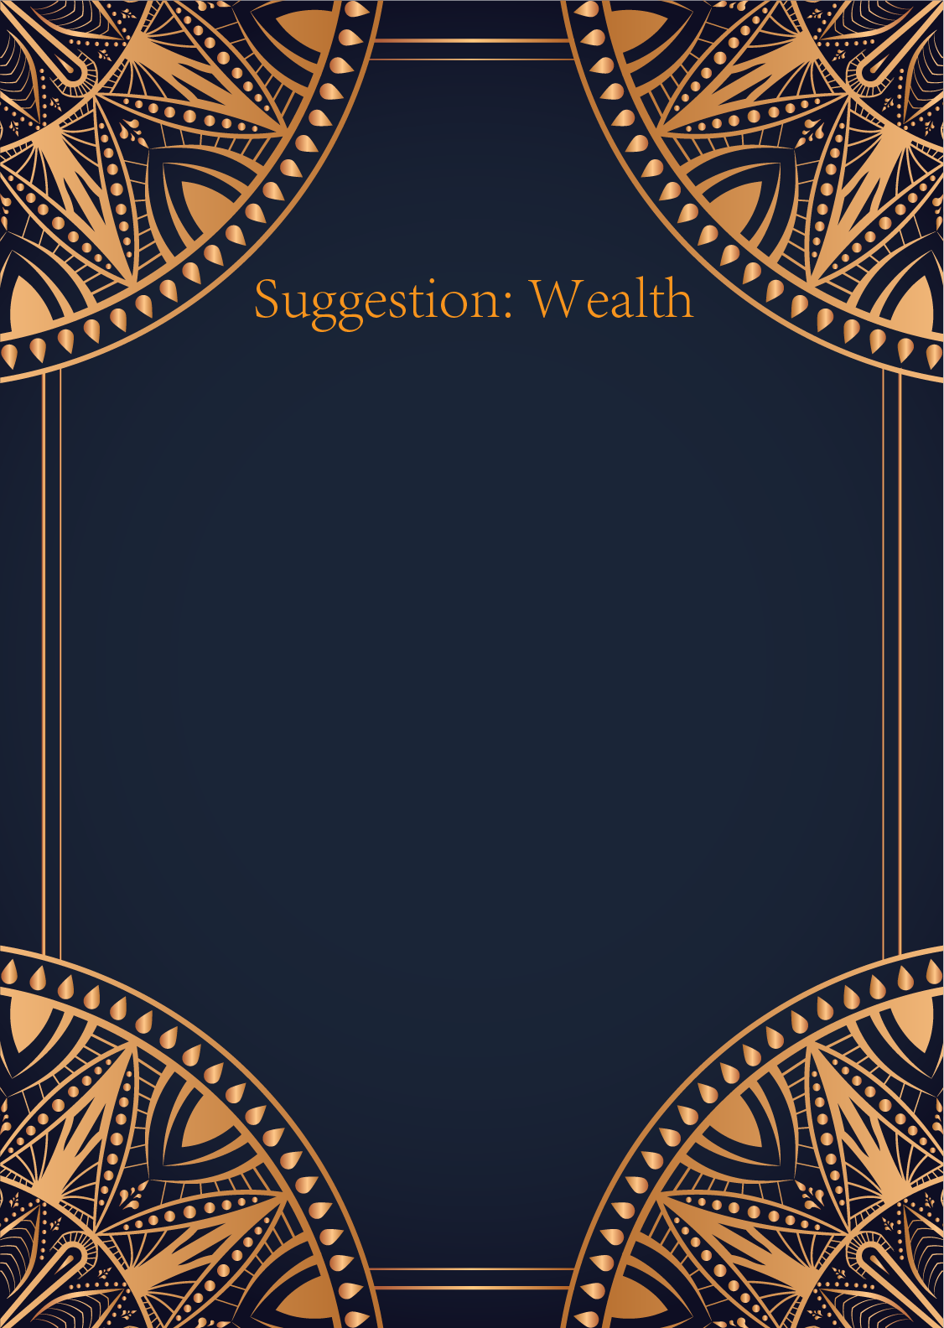

|  |
| --- |
| Ah, dear seeker, the cards have revealed to us a powerful message in the realm of finances. The Sun, the Moon, and the Star, three celestial beings guiding you towards financial enlightenment.   The Sun card shines brightly upon you, illuminating your path to prosperity and success. It heralds a time of abundance and financial growth. It advises you to embrace opportunities with confidence and optimism, for good fortune is on your side. Do not shy away from taking risks, for now is the time to shine and bask in the glory of your financial achievements.  The Moon card, with its mysterious and intuitive energy, reminds you to trust your instincts when it comes to handling your finances. Pay attention to hidden aspects and illusions that may cloud your judgment. Be wary of deception or unclear motives in financial matters. By tapping into your intuition and acknowledging your fears, you can navigate the murky waters of financial uncertainty with grace and wisdom.  Lastly, the Star card glimmers with hope and inspiration, guiding you towards your financial dreams and aspirations. It encourages you to set clear goals and believe in the power of manifestation. Trust in the universe to provide you with all that you need to achieve financial fulfillment. Stay true to your vision and never lose sight of the guiding light that leads you towards abundance and prosperity.  In conclusion, dear seeker, the cards urge you to embrace the opportunities that come your way with confidence and optimism. Trust your intuition, navigate financial uncertainties with wisdom, and believe in the power of manifestation to achieve your financial goals. Remember, you are a shining star in the vast universe of abundance and opportunity. Embrace the journey towards financial prosperity with grace and courage. |

